新概念 3 册
Lesson38 The first calender



Book
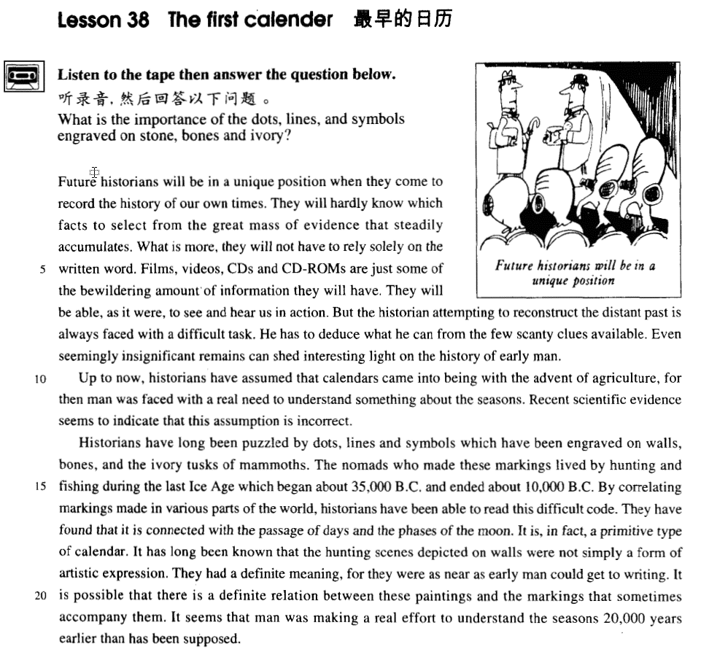

课文
Future historians will be in a unique position when they come to record the history of our own times.
未来的历史学家在写我们这一段历史的时候会别具一格。

They will hardly know which facts to select from the great mass of evidence that steadily accumulates.
对于逐渐积累起来的庞大材料，他们几乎不知道选取哪些好，

What is more, they will not have to rely solely on the written word.
而且，也不必完全依赖文字材料。

Films, videos, CDs and CD-ROMs are just some of the bewildering amount of information they will have.
电影、录像、光盘和光盘驱动器只是能为他们提供令人眼花缭乱的大量信息的几种手段 。

They will be able, as it were, to see and hear us in action.
他们能够身临其境般地观看我们做事，倾听我们讲话。

But the historian attempting to reconstruct the distant past is always faced with a difficult task.
但是，历史学家企图重现遥远的过去可是一项艰巨的任务，

He has to deduce what he can from the few scanty clues available.
他们必须根据现有的不充分的线索进行推理。

Even seemingly insignificant remains can shed interesting light on the history of early man.
即使看起来微不足道的遗物，也可能揭示人类早期历史的一些有趣的内容。

Up to now, historians have assumed that calendars came into being with the advent of agriculture, for then man was faced with a real need to understand something about the seasons.
历史学家迄今认为日历是随农业的问世而出现的，因为当时人们面临着了解四季的实际需要。

Recent scientific evidence seems to indicate that this assumption is incorrect.
但近期科学研究发现，好像这种假设是不正确的。

Historians have long been puzzled by dots, lines and symbols which have been engraved on walls, bones, and the ivory tusks of mammoths.
长期以来，历史学家一直对雕刻在墙壁上、骨头上、古代长毛象的象牙上的点、线和形形色色的符号感到困惑不解。

The nomads who made these markings lived by hunting and fishing during the last Ice Age which began about 35,000 B.C. and ended about 10,000 B.C.
这些痕迹是游牧人留下的，他们生活在从公元前约35，000年到公元前10，000年的冰川期的末期，以狩猎、捕鱼为生。

By correlating markings made in various parts of the world, historians have been able to read this difficult code.
历史学家通过把世界各地留下的这种痕迹放在一起研究，终于弄懂了这种费解的代码。

They have found that it is connected with the passage of days and the phases of the moon.
他们发现代码与昼夜更迭和月亮圆缺有关，

It is, in fact, a primitive type of calendar.
事实上是一种最原始的日历。

It has long been known that the hunting scenes depicted on walls were not simply a form of artistic expression.
大家早就知道，画在墙上的狩猎图景并不是单纯的艺术表现形式，

They had a definite meaning, for they were as near as early man could get to writing.
它们有着一定的含义，因为它们已接近古代人的文字形式。

It is possible that there is a definite relation between these paintings and the markings that sometimes accompany them.
有时，这种图画与墙壁上的刻痕共存，它们之间可能有一定的联系。

It seems that man was making a real effort to understand the seasons 20,000 years earlier than has been supposed.
看来人类早就致力于探索四季变迁了，比人们想像的要早20,000年。

词汇讲解
- calendar ['kælɪndə(r)] n. 日历

solar calendar 阳历
lunar calendar 阴历
Chinese calendar 农历
perpetual calendar 万年历
desk calendar 台历
wall calendar 挂历

- unique [ju'ni:k] adj. 唯一的，独一无二的
- a unique position 唯一的地位
- Each person’s DNA is unique.

be unique to ... 对…独有的
- Fingerprints are unique to every individual.

【扩展】
be peculiar to ... 是…独有的
- Pandas are peculiar to China.

be confined to ... 局限于…
- ..., for collectors are not confined to any one country.

be limited to ... 局限于…
- The air strikes are limited to military targets.

be restricted to ... 限制于…范围之类
- Access to the company files is restricted to management.

- solely ['səʊlli] adv. 唯一地
sole adj.仅有的；唯一的
- He is the sole survivor of the car accident.

【近义词组】表达“唯一的”：
only
single
- ... to this day it has never written a single word.

lone
solitary
- Owen scored the lone goal of the match.
- They had a single aim, a solitary goal, the top.

- bewilder [bɪ'wɪldə(r)] v. 令人眼花缭乱，晕头转向 （同时出现众多的人或事物）
- Big city traffic bewildered the country girl.

bewildering adj.令人困惑的；使人糊涂的
- the bewildering amount of information confuse

注意：“…ing”做形容词一般表示“令人…”，形容事物的特征；“…ed”做形容词表示人的感受

【近义词组】表达“糊涂的；迷惑的”：
confused adj.（强调选择太多）糊涂的；迷惑的
- They confused me with their conflicting advice.
confusing adj.难以理解的；不清楚的

- 6级真题：
- Many tourists were ___B___ by the city’s complicated traffic system.
(A) degraded (B) bewildered
(C) evoked (D) diverted

- 考研阅读真题：
- As an increasing number of traffic regulation schemes are devised, the poor bewildered driver finds himself diverted and forced into one-way systems which cause even greater delays than the traffic jams they are supposed to prevent.

【近义词组】表达“令人迷惑的”：
puzzle （强调本身难度特别大）
perplex （强调本身难度特别大）
baffle （强调本身难度特别大）

- The murder case still puzzled / perplexed / baffled the police.

puzzling adj.
perplexing adj.
baffling adj.

- deduce [dɪ'dju:s] v. 推理，推断
deduce ... from ... 由后者推断出前者
- I can deduce his motives from his behavior.

deduction n.演绎；推论；推理

【近义词组】表达“推理，推断”：
conclude ... from ... 由后者推断出前者
- What do you conclude from the evidence?

conclusion n.结论；推论 （Lesson36）

infer ... from ... 由后者推断出前者
- What can we infer from the passage?

inference n. 推断的结果；结论

- scanty ['skænti] adj. 不足的，匮乏的
scanty clues 匮乏的线索
scanty evidence 不足的证据

【近义词组】表达“匮乏的、缺乏的”：
scant 一丁点的；微小的；不足的；欠缺的
insufficient 不充分的；不足的；不够重要的
inadequate 不充分的；不足的；不够的
scarce （日常用品）缺乏的；不足的；稀少的
- Food and clean water were becoming scarce.

【反义词组】
sufficient 足够的；充足的
adequate 够的；合格的；合乎需要的

【近义词组】表达“稀少的、罕见的”：
rare 稀少的；稀罕的
- a rare disease / species

sparse 稀少的；稀疏的；零落的
- a sparse population
- sparsely-populated regions 人口稀少的地区

be deficient in ... 某个物质比较缺乏
- a diet deficient in vitamin C

be few and far between （表示人或事物）少见的
- People like John are few and far between.
- Thank God people like John are few and far between.

- engrave [ɪn'greɪv] v. 雕刻（强调硬物的表面上）
- Historians have long been puzzled by dots, lines and symbols which have been engraved on walls, bones, and the ivory tusks of mammoths.

【近义词组】表达“雕刻”：
inscribe (刻字) （Lesson28）
- At the base of the gold cap, the words 'made in the U.S.A' had been neatly inscribed.

sculpt 雕刻；雕塑
sculpture 雕像；雕塑品；雕刻品
etch 蚀刻，凿出（玻璃、金属等上的文字或图画）

be etched / engraved on / in one’s memory 某人永远不能忘记某个事情
- The scene will be etched / engraved on / in my memory forever.

- correlate ['kɒrəleɪt]v. 使相互联系（强调A变化，B跟着变化）
- Stress levels and heart disease are strongly correlated.

【辨析】
relate 联系；使有联系；把 … 联系起来 （未必跟着变，不是动态关联）
- Cancer cases in the area are directly related to the new nuclear power station.

【同根词】
correlation n. 相互关系；相关；关联
correlation between A and B
- There’s a high correlation between smoking and lung cancer.

单词：单词比语法更加复杂；包含搭配、拼写、使用场合

课文讲解

（第一段）

Future historians will be in a unique position when they come to record the history of our own times.

知识点（1）
【总结】表达“未来的”：
husband-to-be 未婚夫
fiancé 未婚夫
bride-to-be 未婚妻
fiancée 未婚妻
posterity 后代
- These works of art are preserved for posterity.

in the near / not-too-distant future 在不远的将来
in the foreseeable future 在可以遇见到的将来

【扩展】
in the long run 从长远来看
in the short run 从短期来看
- Taking this decision will cost us more in the short run, but will be beneficial in the long run.

【扩展】
modern historians 当代的历史学家
today’s historians 当代的历史学家
historians of today 当代的历史学家
contemporary historians 当代的历史学家

知识点（2）
position: situation 地位、状况、处境
- She’s in the enviable position of being able to choose who she works with.
- When two of your best friends argue it puts you in a very awkward position.

in a delicate position 处境很微妙
in a dominating position 处于统治地位
in a favorable position 处于有利地位
in an adverse position 处于不利地位
China’s world position 处于世界的地位

知识点（3）
come to do sth. 1.开始做某事；2.偶然的
- I’ve come to like her over the months.（开始做某事）
- A body came to be found under the bridge.（偶然的）

知识点（4）【课文仿写】
- 造句: 在计算机的帮助下,当代的科学家在开始进行复杂运算的时候处于得天独厚的地位。
- With the assistance of computers, contemporary scientists are in a unique position when they come to make complicated calculations.

They will hardly know which facts to select from the great mass of evidence that steadily accumulates.

语法分析：
They will hardly know which（which…宾语从句） facts to select from the great mass of evidence that steadily accumulates（定语从句）.

知识点（1）
语法：“疑问词 + to do”可以视为名词性从句的缩略形式
1、相当于宾语从句
- They will hardly know which facts to select from …
- 相当于： They will hardly know which facts they should select from …

- I don’t know what to do.
- 相当于： I don’t know what I should do.

- I haven't decided whether to sell it or not.
- 相当于： I haven't decided whether I should sell it or not.

- Have you settled where to go?
- 相当于：Have you settled where you should go?

2、相当于主语从句
- Who to turn to is what she wants to know.
- 相当于：Who she should turn to is what she wants to know.

3、相当于表语从句
- The problem she faces is which way to take.
- 相当于：The problem she faces is which way she should take.

4、相当于同位语从句
- The problem which course to take worried Lucy for hours.
- 相当于：The problem which course she should take worried Lucy for hours.

知识点（2）
mass: a large quantity or number 大量的
a mass of ... / masses of ... （可以修饰可数名词和不可数名词）
= a lot of… / lots of … （可以修饰可数名词和不可数名词）

- the great mass of evidence
- Traditional custom, taken the world over, is a mass of detailed behavior more astonishing than what any one person can ever evolve in individual actions, no matter how aberrant.
- This caused the construction of gigantic buildings where too large masses of human beings are crowded together.

the masses 人民群众
- It is an entertainment that will appeal to the masses.

- mass education 群众教育
- the problem of mass unemployment 大规模失业问题
- weapons of mass destruction 大规模杀伤性武器
- mass communication 大众传播

知识点（3）
steadily 平稳的、不断地

【近义词组】表达“平稳的、不断地”：
ever-doing adj. 不断……的 （做前置定语）
- We have to ask ourselves very seriously what will happen if this two-fold use of knowledge with its ever-increasing power continues.

- 课文写法替换：
- … evidence that steadily accumulates
- … the ever-accumulating evidence

- the world that steadily changes
- the ever-changing world

- the knowledge that steadily grows
- the ever-growing knowledge

- the economy that steadily develops
- the ever-developing economy

- the market that steadily expands
- the ever-expanding market

- the reform that steadily deepens
- the ever-deepening reform

- the resources that steadily dwindle
- the ever-dwindling resources

What is more, they will not have to rely solely on the written word.

知识点（1） Lesson15
what is more / what’s more 而且，还，（没有感情色彩，递进）

- He could not find his fifty pence piece anywhere, and what is more, he could not get his arm out.

【近义词组】表达“此外，而且”，（没有感情色彩）
moreover / furthermore
besides
in addition
additionally

【近义词组】表达“更糟的是…”，（有感情色彩）
better still （放在句首）
worse still
to make things worse
to make matters worse

【扩展】
stranger still 更奇怪的是
- During these tests she was able to read a newspaper through an opaque screen and, stranger still, by moving her elbow over a child's game of Lotto she was able to describe the figures and colours printed on it; …

知识点（2）Lesson3
【近义词组】表达“基于，依赖于…”：
rely on ...
depend on ...
bank on ...
count on ...
hinge on ...
rest on ...
build on ...
ride on ...
reliance on …

知识点（3）
the written word 书面语
= written language

a written agreement / statement 书面声明

the spoken word 口语
= spoken language

oral / verbal 口头的
- an oral exam 口试
- a verbal agreement 口头协议

Films, videos, CDs and CD-ROMs are just some of the bewildering amount of information they will have.

They will be able, as it were, to see and hear us in action.

知识点（1）
as it were 可谓说是、仿佛是
- He is, as it were, a walking dictionary.

- 4级阅读真题：Lesson27
- Reading is thought to be a kind of conversation between the reader and the text. The reader puts questions, as it were, to the text and gets answers. In the light of these he puts further questions, and so on.

- The Han nationality and the minority nationalities are all, as it were, members of the same family.

【扩展】
so to speak 可以说；可谓
- He is, so to speak, a walking dictionary.
- The Han nationality and the minority nationalities are all, so to speak, members of the same family.

【辨析】
as it is 照现状、看样子、照目前情况来看
- I thought things would get better, but as it is they are getting worse.

知识点（2）
in action 1. 在活动中；在运转；2.在战斗中
- His father told everybody that Eric had been killed in action（在战斗中）.

But the historian attempting to reconstruct the distant past is always faced with a difficult task.

语法分析：
But the historian attempting to reconstruct the distant past（非谓语动词做后置定语,修饰historian） is always faced with a difficult task.

知识点（1）
reconstruct 修复；重建；重造
- When the archaeologists reconstructed the fragments, they were amazed to find that the goddess turned out to be a very modern-looking woman.
piece together 组合资料（以便了解情况）; 拼凑；拼合
- From this the captain was able to piece together all the information that had come to light.

- 课文写法替换：
- But the historian attempting to piece together the distant past ...

知识点（2）
be faced with … 面临着…（棘手的问题）
- … for then man was faced with a real need to understand something about the seasons.
- They were expecting their sixth child and were faced with even more pressing economic problems.
- After buying a new chain I was faced with the insurmountable task of putting the confusing jigsaw puzzle together again.

【近义词组】表达“面临着…”：
be confronted with ... 面临着…（棘手的问题）
- But if the animals are confronted with situations they have no control over, they later behave passively when faced with experiences they can control.

He has to deduce what he can from the few scanty clues available.

语法分析：
He has to deduce what he can（宾语从句） from the few scanty clues available（后置定语,修饰clues）. （from... 状语）

知识点（1）
语法：…able (ible) 形容词后置；这种形容词位置灵活，可以放在名词前面和后面；尤其是名词前有形容词修饰的时候，一般后置
- the most democratic form of ‘college’ imaginable
- the most civilized society conceivable
- the most talented person available
- the farthest star visible

Even seemingly insignificant remains can shed interesting light on the history of early man.

知识点（1）
seemingly 表面上的
- We often read in novels how a seemingly respectable person or family has some terrible secret which has been concealed from strangers for years.

知识点（2）Lesson32
shed / throw / cast light on sth. 揭示…
- 6级真题：
- Figuring out how humans acquire language may shed light on why some children learn to read and write later than others.

- 6级阅读真真题：
- Groundbreaking research by two French geophysicists promises to shed some light on the mystery.

come to light 被发现、被了解
- From this the captain was able to piece together all the information that had come to light.

视觉原理相关：
- One of the most colorful figures in boxing history was Daniel Mendoza, who was born in 1764.
- The devastating floods of two years ago pale in comparison with last week’s storms.

（第二段）

Up to now, historians have assumed that calendars came into being with the advent of agriculture, for then man was faced with a real need to understand something about the seasons.

语法分析：
Up to now（时间状语）, historians have assumed（暗示不正确，Lesson36） that calendars came into being with the advent of agriculture（宾语从句内的时间状语） （that…宾语从句）, for then man was faced with a real need to understand something about the seasons（后置定语,修饰need）. （for...原因状语)

知识点（1）
come into being 开始存在、产生了
be 有；存在
- To be or not to be, that is the question. — William Shakespeare ‘Hamlet’
- I think therefore I am.
【复习】 表达“进入某种状态”：Lesson29
come into being 开始存在
come into fashion 开始流行
come into use 开始使用
come into effect 开始生效
come into blossom 开始开花

知识点（2）
advent （重要事件、人物、发明等的）出现，到来
the advent of sth. / sb. 重要事件或人物的到来
- The advent of the steam engine heralded the beginning of a new era.
- With the advent of the new chairman, the company began to prosper. with the advent of ...

【近义词组】表达“随着…的到来”：
with the coming / arrival of ...
with the birth of ...
with the genesis of ...

- with the coming of spring 随着春天的到来
- with the approach of Christmas 随着圣诞的临近
- with the outbreak of war 随着战争的爆发
- with the progress of science 随着科学的进步
- with the evidence began to accumulate X with是介词，后面不能跟句子
- As the evidence began to accumulate, experts from the zoo felt obliged to investigate, …

Recent scientific evidence seems to indicate that this assumption is incorrect.

知识点（1） Lesson28
indicate 表明；标示；显示（一般强调语言文字之外的方式）
- I shook my head and held up five fingers indicating that I was willing to pay￡5.

（第三段）

Historians have long been puzzled by dots, lines and symbols which have been engraved on walls, bones, and the ivory tusks of mammoths.

语法分析：
Historians have long（adv. 长期，长久） been puzzled by dots, lines and symbols（介词by的宾语） which have been engraved on walls, bones, and the ivory tusks of mammoths（介词on的宾语）. （which...定语从句，修饰dots…）

知识点（1）
be puzzled by ... （强调本身难度特别大）
= be perplexed by ...
= be baffled by ...

知识点（2）
long adv. 长期，长久
- Doctors have long been puzzled by the rare skin condition.
- It has long been known that the hunting scenes depicted on walls were not simply a form of artistic expression.
- It has long been believed that cats have nine lives.

【近义词组】表达“长期，长久以来”：
- There has long been a superstition among mariners that porpoises will save drowning men by pushing them to the surface, or protect them from sharks by surrounding them in defensive formation.

- 造句：中国人长久以来迷信看见喜鹊会有好运气
- There has long been a superstition among the Chinese that seeing a magpie will bring you good luck / is good omen / is an auspicious omen.

知识点（3）
ivory tower 象牙塔
英文解释：a place or situation where you are separated from the difficulties of ordinary life and so are unable to understand them, used especially to describe a college or university

The nomads who made these markings lived by hunting and fishing during the last Ice Age which began about 35,000 B.C. and ended about 10,000 B.C.

语法分析：
The nomads who made these markings（定语从句，修饰上文） lived by hunting and fishing during the last Ice Age which began about 35,000 B.C. and ended about 10,000 B.C（定语从句）. （during... 时间状语）

知识点（1） Lesson27
live by doing sth. 靠…为生
- It has been said that everyone lives by selling something.

知识点（2）
age 时代、时期
- the Ice / Stone Age 冰川时期/石器时期
- the modern age 当代
- the computer age计算机时代

times
- Roman times 罗马时代
- in modern / recent / ancient / prehistoric times

era / epoch 时代、时期
- the steam-engine era / epoch
- the end of an era / epoch
- His death marked the end of an era.
- the beginning of a new era / epoch
- The foundation of the Republic of China marked the beginning of a new era / epoch.

知识点（3） Lesson3
B.C. / BC Before Christ 公元前
A.D. / AD Anno Domini 公元后

知识点（4）【课文仿写】
- 造句：传说中道教的创始人老子，生活在大约公元前6 世纪至公元前5 世纪春秋时代的晚期， 靠掌管国家图书馆为生。
- Laozi, legendary founder of Daoism, lived by taking charge of the royal library during the late Spring and Autumn Period which began about 600 B.C. and ended about 500 B.C.

By correlating markings made in various parts of the world, historians have been able to read this difficult code.

语法分析：
By correlating markings made in various parts of the world（后置定语,修饰markings） （By... 方式状语）, historians have been able to read this difficult code.

知识点（1）Lesson23
in various parts of the world 世界各地
- Cooked in wine, snails are a great luxury in various parts of the world.

They have found that it is connected with the passage of days and the phases of the moon.

语法分析：
They have found that it is connected with the passage of days（介词with的宾语） and the phases of the moon（介词with的宾语）. （that…宾语从句）

知识点（1）
wax and wane 月亮盈亏
ebb and flow 潮起潮落
up and down 人生起伏
to and fro 来来回回
on and off 断断续续

【古诗汉译英】
With joy and woe people meet and part
人有悲欢离合

With light and shade the moon waxes and wanes
月有阴晴圆缺

Since time immemorial it’s been unchanged
此事古难全

Would that we could live a long life
但愿人长久

And together share the moonlight though thousands of miles apart
千里共婵娟

It is, in fact, a primitive type of calendar.

It has long been known that the hunting scenes depicted on walls were not simply a form of artistic expression.

语法分析：
It（形式主语） has long been known that the hunting scenes depicted on walls（后置定语） were not simply a form of artistic expression. （that...主语从句）

知识点（1）
depict v. 1. 描绘，描画；2. 描写
- a picture depicting （描绘，描画）him as a clown
- The novel depicts（描写） French society in the 1930s.

They had a definite meaning, for they were as near as early man could get to writing.

语法分析：
They had a definite meaning, for they were as near as early man could get to writing. （for...原因状语)

知识点（1）
definite 肯定的；确定的；不会改变的
- a definite meaning 确切的含义
- a definite answer 明确的回答
- definite article 定冠词

【反义词】
indefinite 1.无限期的；期限不定的；2. 模糊不清的；不明确的
- indefinite article 不定冠词
- an indefinite prison term 无期徒刑

【辨析】
definitive 1. 最后的；决定性的；不可更改的；2. 最佳的；最完整可靠的
- a definitive judgment 终审裁决
- a definitive diagnosis 最终诊断
- a definitive guide book 最好的导游书

finite 有限的；有限制的
- Human knowledge is finite.

infinite 极大的；无法衡量的
- The universe is infinite.

infinitive 动词的）不定式，不定词

知识点（2）
get to doing sth. 开始做某事，to介词
=start doing sth.
- He got to thinking that it was all his fault.

It is possible that there is a definite relation between these paintings and the markings that sometimes accompany them.

语法分析：
It（形式主语） is possible that there is a definite relation between these paintings and the markings that sometimes accompany them（定语从句，修饰markings）. （that...主语从句）

知识点（1）
accompany 陪伴；伴随
- Having left the bag in the hall, I accompanied Robert into the living room.
- The disease is accompanied by sneezing and fever.

It seems that man was making a real effort to understand the seasons 20,000 years earlier than has been supposed.

语法分析：
It seems that man was making a real effort to understand the seasons 20,000 years earlier than has been supposed（比较状语）（20,000 years……时间状语）. （that...主语从句；或者可以看作表语从句）

知识点（1）
make an effort to do sth. 努力做某事
spare no effort to do sth. 不遗余力做某事

知识点（2）Lesson29
语法：than后接谓语动词
- ... than what（可以看做what被省略） has been supposed.
- To compensate for his unpleasant experiences in hospital, the man drank a little more than was good for him.

- 考试真题：
- The project requires more labor than ___A___ because it is extremely difficult.
A．has been put in
B．have been put in
C．being put in
D．to be put in

- 考试真题：
- We often advise him not to drink more wine ___B___ is good for his health.
A．as
B．than
C．that
D．but

- 考试真题：
- The experiment requires more money than ___C___.
A．have been put in
B．being put in
C．has been put in
D．to be put in

- 考试真题：
- The indoor swimming pool seems to be a great deal more luxurious than ___A__.
A．is necessary
B．being necessary
C．to be necessary
D．it is necessary

